5GCAR

Muhammet Şeramet

*Faculty of Electrical Engineering and Informatics*

*BME University*

*Budapest, Hungary*

[muhammetseramet@edu](mailto:1first.author@first-third.edu).bme.hu

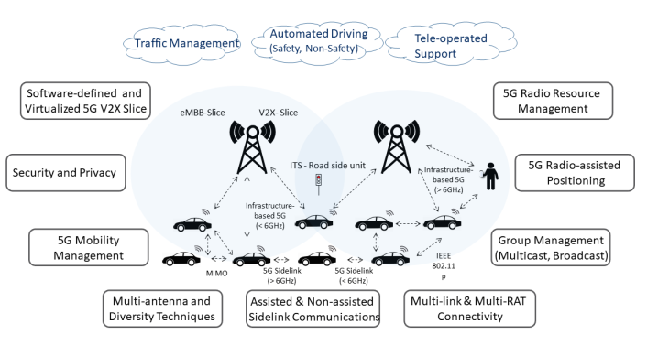

***Abstract*— This document discusses the position of 5G technologies for the connected car, 5G will enable to cars and vehicles to be connected to the networks and also to be able to talk to each other with high reliability and low latency. Cooperative and connected vehicles will lead to improved road traffic safety and efficiency and it will also trigger innovation in transformation of the automotive sector. Among other efforts, the European-funded 5GCAR project is looking more promising into such V2X technology components and enablers.**

***Keywords***— **V2X, 5GCAR, 5G**

1. INTRODUCTION

Two strong technology trends, one in the mobile communications industry and one in the automotive industry, are becoming more and more interwoven and will jointly provide new capabilities and functionalities for upcoming intelligent transport systems (ITS) and future driving.

The automotive industry is on a path where vehicles are continuously becoming more aware of their environment due to the addition of various types of integrated sensors. At the same time, the amount of automation in vehicles increases, which – with some intermediate steps – will eventually culminate in fully-automated driving without human intervention. Along this path, the amount of interactions increases, both in between vehicles, between vehicles and other road users, and with an increasingly intelligent road infrastructure. As a consequence, the significance and reliance on capable communication systems for vehicle to anything (V2X) communication is becoming a key asset that will enhance the performance of automated driving and increase further road traffic safety with combination of sensor-based technologies [1].

On the other hand, over the last 25 years the mobile communications industry has connected more than five billion people. Today, mobile (smart) phones have become a part of our daily lives and connectivity is highly ubiquitous. The next step in wireless connectivity aims at connecting all kinds of things, machines and devices. The development of the next generation of mobile wireless communications, the so-called 5G technology, aims at offering a technical framework to the challenge of connecting people and devices in a single common communications network infrastructure, to complement existing LTE and evolved-LTE for more demanding use cases. 5G aims at offering efficient and reliable communications for three kinds of services: 1) evolved mobile broadband, 2) ultra-reliable low-latency communications, and 3) massive machine-type communications. Therefore, 5G will enable the connection of all kind of devices to the communication networks; vehicles are an important part of this vision. The interconnection and Internet connection of vehicles enables wide set of innovations that will change the automotive industry forever [2].

Figure 1: The 5GCAR concept and its technical components

Figure 1 illustrates the 5GCAR concept and its key technical components, such as 5G Radio Resource Management, 5G radio-assisted positioning, Multilink and multi-RAT connectivity, (non-)/assisted Sidelink, Diversity techniques, 5G mobility management, SDN- defined 5G V2X slice, Security and Privacy.

1. 5GCAR DEMONSTRATIONS

The 5GCAR project identified five use case classes in [5GC19-D21], which are illustrated in Figure 2.1. As representatives of these use cases, four different demonstrations were implemented as field tests and showcased in an event on June 27, 2019. These use cases are:

1. *Lane Merge Coordination, from the Cooperative Maneuver use case class*
2. *See-Through Sensor Sharing, from the Cooperative Perception use case class*
3. *Long Range Sensor Sharing, also from the Cooperative Perception use case class*
4. *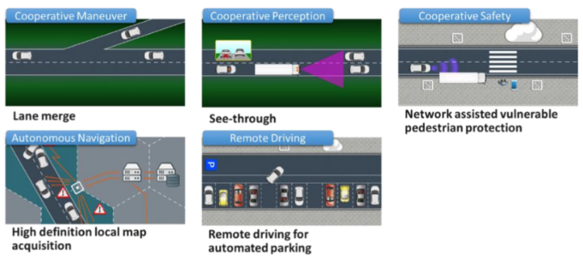Vulnerable Road User Protection, from the Cooperative Safety use case class*

Figure 2.1: Five use case classes from [5GC19-D21], based on which four demonstrations were showcased and evaluated in field tests

1. *Lane Merge Coordination*

The Lane Merge Coordination use case deals with the orchestrated creation of gaps for cars entering motorway, using cellular communication and a centralized lane merge coordination function. In the implemented scenario, a fixed camera installation near the merging point is used to detect vehicles that are not connected, and thus cannot receive

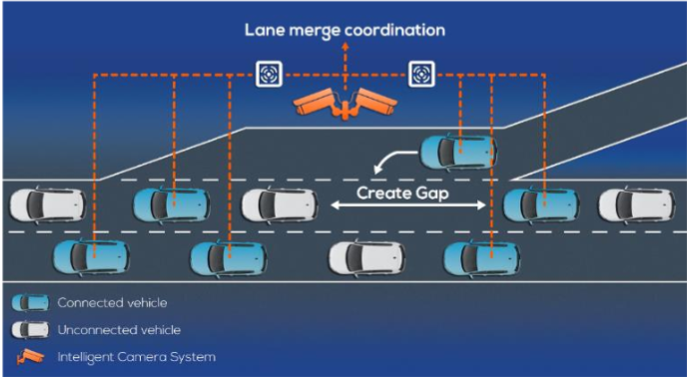instructions or communicate information about themselves, as illustrated in Figure2.2.

Figure 2.2: In the line merge coordination use case, a central coordination entity plans the creation of a gap for vehicles entering a motorway

In the demonstration work of the project, a complete system capable of combining input from connected vehicles and roadside cameras and devising individual maneuvers was implemented and evaluated. Communication-wise, all road users were connected using an experimental cellular network, implementing 5G deployment models, namely edge computing, network slicing, and QoS. Several KPIs were evaluated, from both the automotive and the communication domain, where the focus was set on the latency performance and dependencies in the system. It was shown that the latency contribution by the radio access is significant, but other contributors are at least as significant, mainly the deployment of components (should be coordinated, preferably in an edge cloud), the aggregation of data from multiple inputs for the data fusion, and the proper configuration of higher layer protocols for low latency operation [3].

1. *See-Trough Sensor Sharing*

The cooperative perception demonstration shows the benefit of vehicle-to-infrastructure and vehicle-to-vehicle communication for enabling, respectively, long-range and short-range sensor sharing between vehicles for safer and more efficient maneuvers.

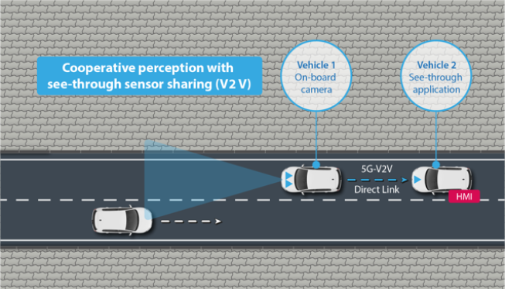The short term-range sensor sharing scenario enabled by a “see-trough” application which uses low-latency video streaming from an on-board camera of a vehicle to allow a rear vehicle to see through it, thereby enabling a safer or more efficient overtaking maneuver. The low-latency video streaming is realized by highly reliable and low latency direct communication between two vehicles [4].

Figure 2.3: See-trough sensor sharing (V2V)

1. *Long Range Sensor Sharing*

The long range sensor sharing is enabled by an on-board camera and sensor-fusion system that detects all, connected as well as unconnected, vehicles in the vicinity and shares this information over the cellular network to nearby vehicles. Thus, the perception of the latter is extended resulting in

more informed maneuver decisions, particularly while navigating blind intersections.

Figure 2.4: Long Range Sensor Sharing

1. *Vulnerable Road User Protection*

The vulnerable road user protection aims at extending today’s vehicle-internal VRU protection systems, which are limited in challenging scenarios such as dense urban settings with non-line of sight between vehicle and VRU, which is a limitation of vehicles’ on-board sensors. To address this, a network-based positioning and collision prediction system is established. The targeted scenario is a crosswalk over an urban road, where a pedestrian is walking toward to zebra-crossing from one side of the street, and the vehicle approaches the zebra-crossing, although many other scenarios are possible under discussion before the before the final demonstration. The vehicle and the pedestrian send proprietary broadband 5G uplink reference signals to several base stations, and each base station then measures the time of arrival of the signals to allow triangulation of the vehicle and pedestrian positions. Additionally, the vehicle and the pedestrian provide sensor data, such as GPS measurements, speed, yaw rate, and orientation. All of this information is fused in a network element which estimates the trajectories of the users based on a motion model and a map. Finally, an alert message is triggered if a potentially critical situation is detected, and a corresponding warning is transmitted from the network to the vehicle and the pedestrian a special human machine interface in the vehicle and the communication device and the pedestrian makes them aware about the upcoming dangerous situation. All tests are executed off public roads, where privacy laws are respected, and the safety of all participants is ensured. The pedestrian VRU in the demo specially will be a dummy.

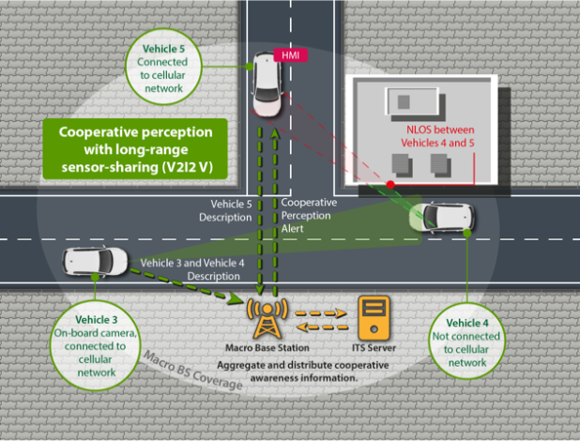

Figure 2.5: Vulnerable Road User Protection (VRU)

1. CONCLUSION

This paper has given an introduction to the activities within 5GCAR project, which aims at contributing to the design of a 5G technology which can satisfy the needs of an automotive industry which is aiming at enabling new services based on cooperative and connected vehicles. The aim of 5GCAR is to provide technical solutions which can enable a 5G network capable of delivering very low latencies below 5ms, very high reliability (99.99%), and radio-assisted positioning techniques which can guarantee accuracies below 1 meter. All this has to be achieved at very high vehicle speeds, even in very high

vehicle densities, in order to support of a broad range of V2X services which can thus foster the development of innovative business models and facilitate the market revolution that is to come in the mobility industry.

REFERENCES

1. Mikael Fallgren, Markus Dillinger, Jesus Alonso-Zarate, Mate Boban, Taimoor Abbas, Konstantinos Manolakis, Toktam Mahmoodi, Tommy Svensson, Andres Laya, Riracrd Vialta “5G Technologies for the Connected Car”

<https://zenodo.org/record/2531786> .

1. Mikael Fallgren, Markus Dillinger, Zexian Li, Guillaume Vivier, Taimoor Abbas, Jesus Alonso-Zarate, Toktam Mahmoodi, Sylvain Allio, Tommy Svensson, Gabor Fodor “On Selected V2X Technology Components and Enablers from the 5GCAR Project”

<https://zenodo.org/record/335912> .

1. Deliverable D1.3 5GCAR Final Project Report

<https://ec.europa.eu/research/participants/documents/downloadPublic?documentIds=080166e5c64b9ab4&appId=PPGMS>.

1. <https://5gcar.eu/wp5-demonstrations/>